**Report [3]**

**Technical Writing**

**Dr. Ahmed Emad ElDin**

**Names:**

* Ibrahim Moustafa Ibrahim Fatouh ElShenhapy

**ID:** 4715 **Period:** Monday 3:20-4:50

* Ahmed Mohamed AbdElKader

**ID:** 4649 **Period:** Wednesday 5:00-6:30

* Mahmoud Adel Osman

**ID:** 4647 **Period:** Monday 3:20-4:50

* Ahmed Mohamed Farouk Ibrahim

**ID:** 4622 **Period:** Monday 5:00-6:30

***Enhancing of Faculty of Engineering’s buildings***

In this proposal, I aim to persuade the administrators of the Faculty of Engineering that some buildings in the faculty are in bad condition due to the effect of time on them and are in need for improvements and maintenance to preserve these building for years to come, as they have a great historical value.

Alexandria’s Faculty of Engineering was one of the first faculties to be built in Egypt , It was built by a great architect thus it has a cultural and historical value that can’t be denied. So there must be a huge maintenance and renovation plan for these important old buildings because it would be a huge loss if they were damaged or destroyed.

Moreover, Preparatory building is an astonishing piece of old architecture, but lack of improvement and protection against climate change and the effect of time has caused lots of damage to the exterior of building as you can see in the pictures below [**Figure 1**] and [**Figure 2**], also the interior of the building needs maintenance like the stairs and , walls of the building and some of the ceilings as shown in [**Figure 3] a**nd [**Figure 4] .**

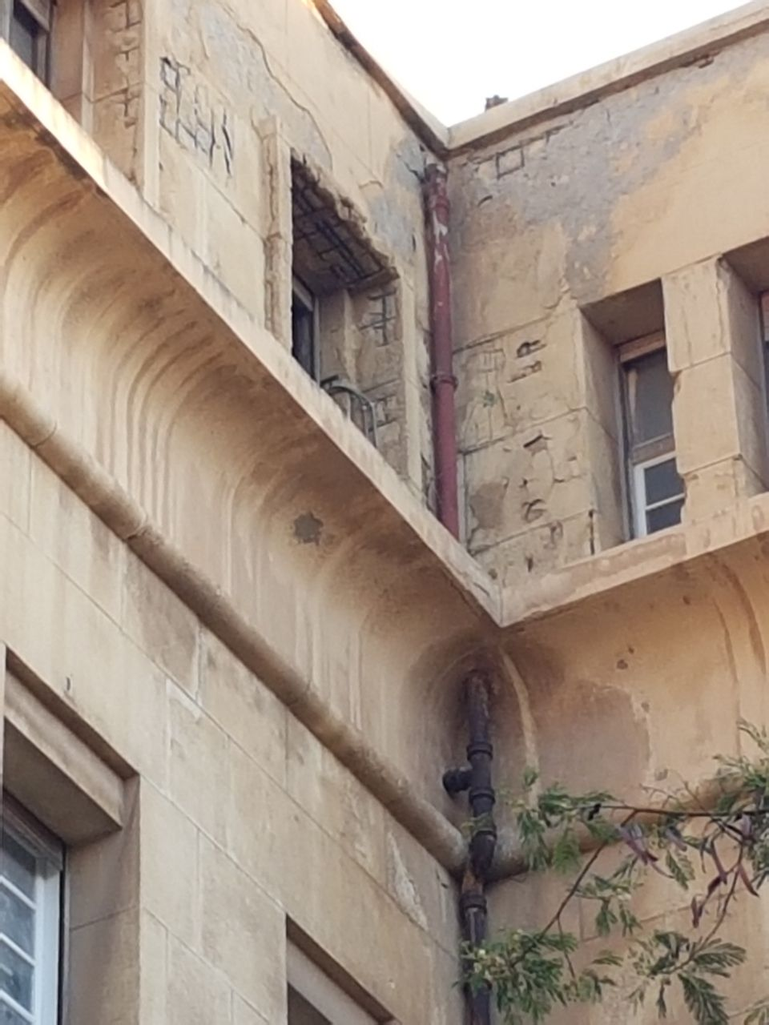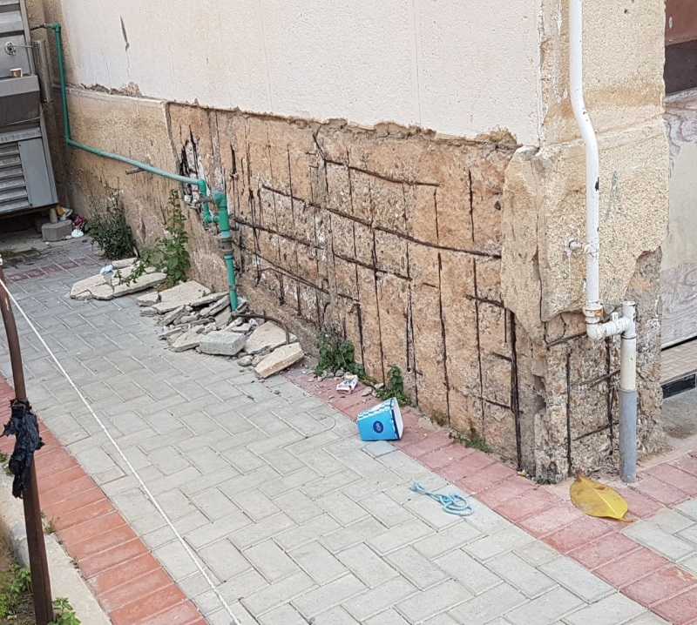

**Figure (1) Leak From Pipes Figure (2) Damaged Walls**

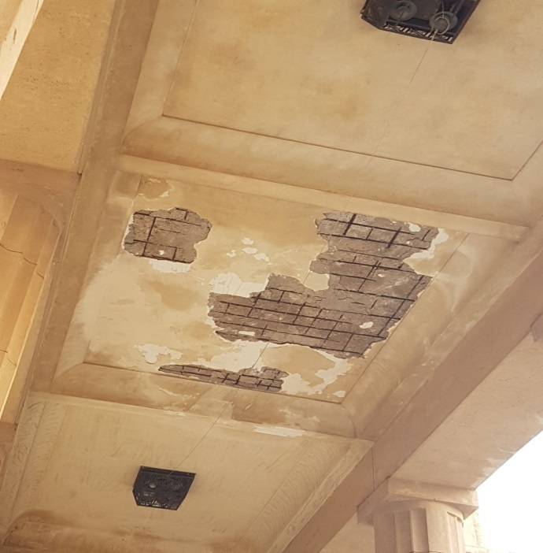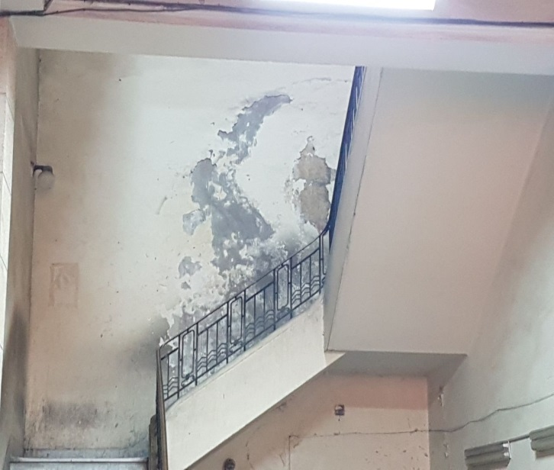 **Figure (3) Bad polish Figure (4) Damaged Ceiling**

Preparatory building is old and I understand that its renovation would be financially demanding, but it needs urgent improvement and maintenance. My plan is to let faculty’s students in the fields of architecture and construction to participate in the process in order to gain practical experience and skills by reconstructing, modernizing and improving this historic building and it must be under the supervision and instructions of our professors and leading engineers in this field.

The development plan will be in the period of the summer vacation, It will be under the supervision of a qualified engineer and his team, the development will start with the exterior of the building , the damaged areas will be reconstructed and whole building will be repainted and renewed, afterwards the working inside the building will begin where the walls will be repainted , the stairs will be repaired, the plumbing will be fixed, the rooms will be provided with air conditioning systems and projectors, the ceilings will be fixed and the electrical system of the building will be renewed.

The team must consist of highly qualified engineers in the field of renovation including: construction engineers, architects and design makers, who will help to improve the students’ practical level and serve as a training for them .the plan should be executed in the summer vacation because the faculty will be empty at that time and reconstruction will be easier, The administrators will take charge of providing the equipment and requirements needed for the renovation which are:

* **General materials:** such as: metals, bricks, cement, concrete and composites. These materials cost about 2250 L.E per square foot.
* **Thermal and moisture protection:** costs about 1000 L.E per square foot.
* **Openings:** including new glass to replace the old broken glass shown in [**Figure 5**] and [**Figure6**], windows, frames and doors, costs about 700 L.E per square foot.
* **Finishes:** including demolition and paintings, cost about 300 L.E per square foot.
* **Additional things:** such as plumbing, electrical components and Heating, ventilation and air-conditioning (HVAC).Also the rooms need new projectors and sound systems. These additional requirements cost about 6000 L.E per room.
* **Workers:** building or renovating involves time to execute, and that time comes at a labor cost. a project as big as this will need a lot of workers to be finish though the time of the summer vacation as the period of time is very short and will involve a lot of workers to finish in time. There must be lots of workers who will cost about 5000 L.E per day.

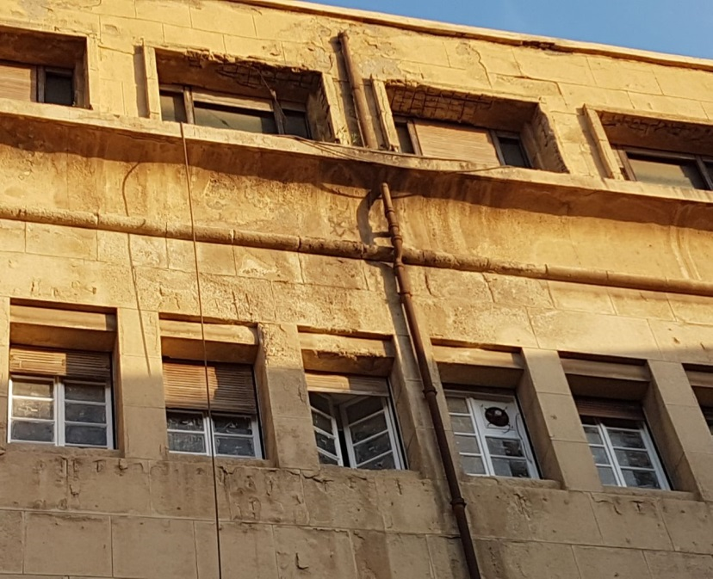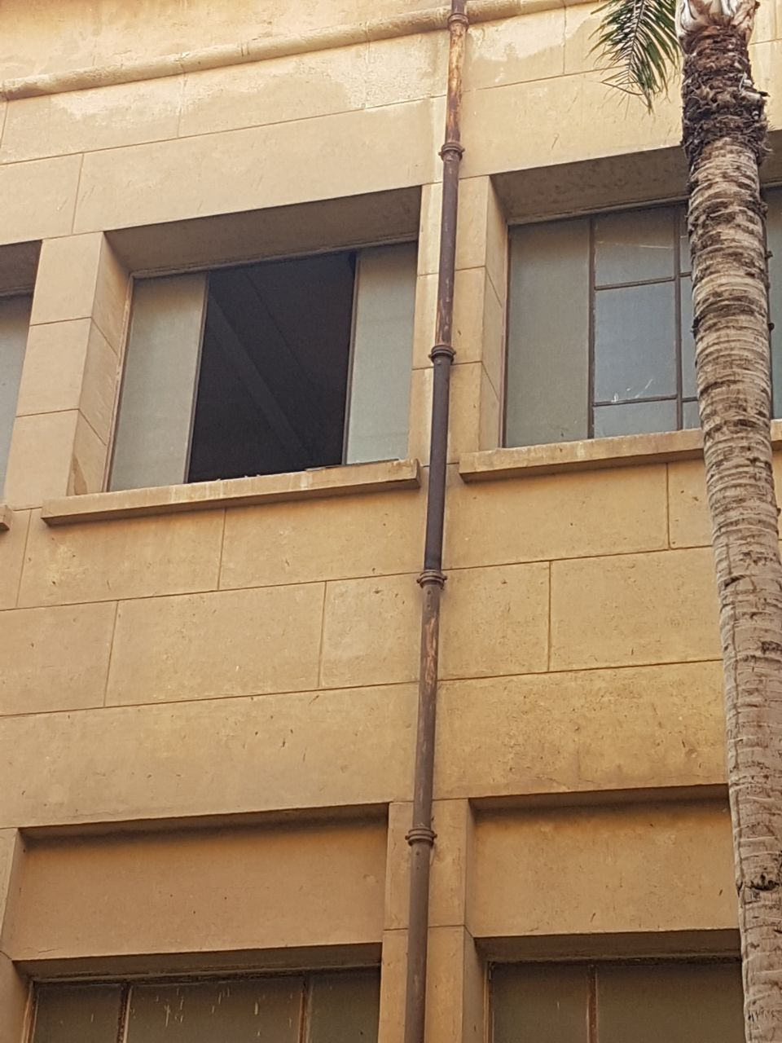

**Figure (5) Rusted Pipes Figure (6) Damaged Pipes**

Apart from SSP building which still hasn't been completed yet as shown in [**Figure 7**], Preparatory building and Mechanical departments building that need much work to be renovated, the rest of the buildings won’t cost a lot. So the total estimated cost for finishing all the building is about 3mil. L.E in a year.

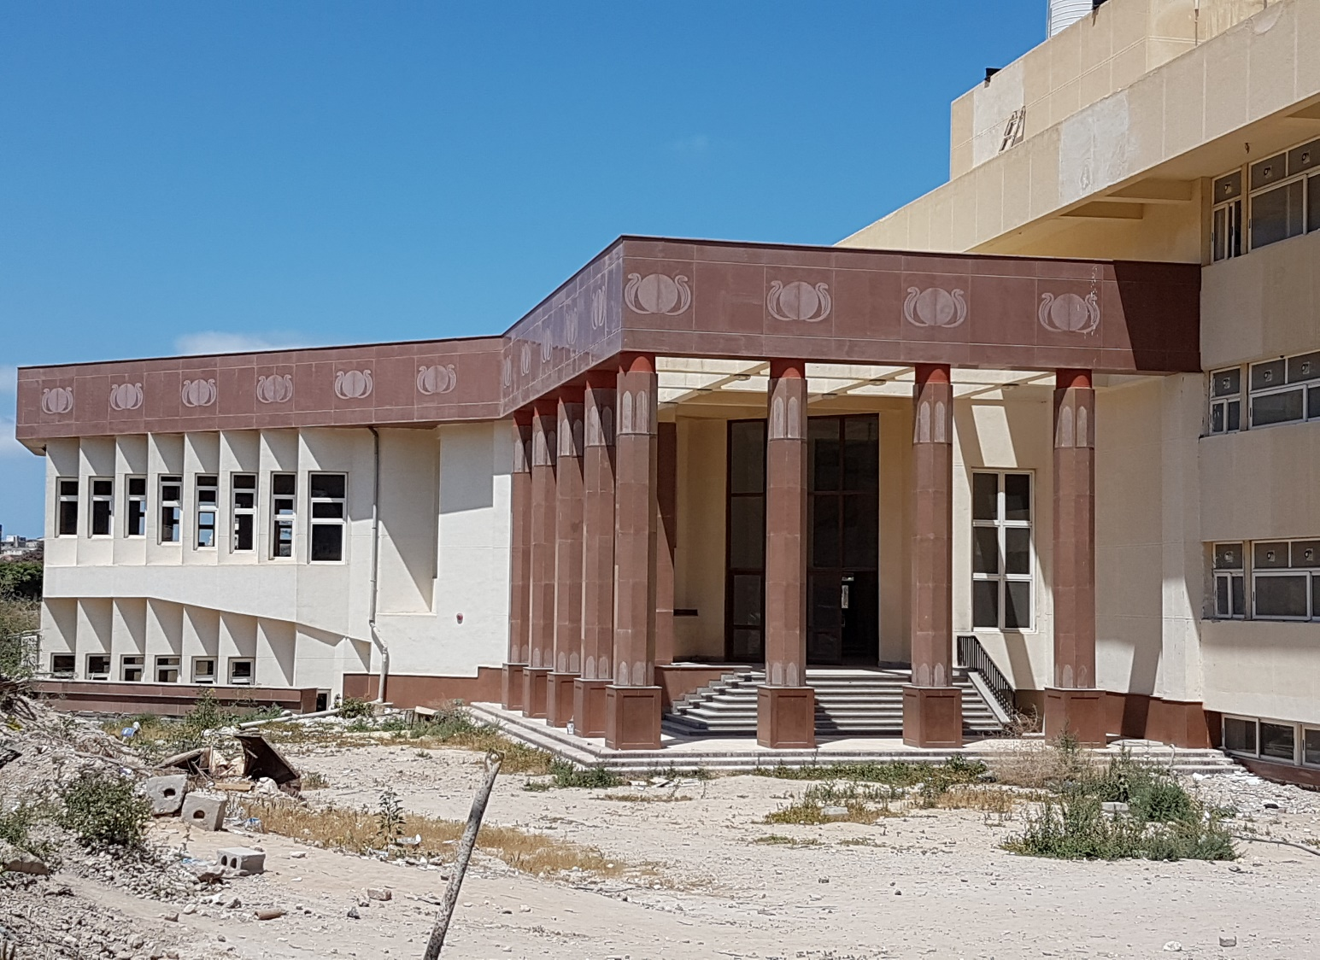

**Figure (7) The New Building**

Finally, I explained my proposal content briefly including all the costs needed for the renovation of the Faculty of Engineering which is considered one of the best engineering universities in the Middle East and its rehabilitation would beneficial for the whole city. That’s why I believe it must be renovated in the shortest possible time that our proposal can handle in a suitable cost.

**Contact:**

* **General manager:** Ibrahim Moustafa Ibrahim Fatouh ElShenhapy

**Phone number:** 01550203799

**E-mail:** [Ibrahim.elshenhapy@gmail.com](mailto:Ibrahim.elshenhapy@gmail.com)

**Best time to contact:** 10:00 a.m. to 5 p.m.

* **Head-Engineer:** Mahmoud Adel Osman

**Phone: 01098886285**

**E-mail:** [m.adel98@gmail.com](mailto:m.adel98@gmail.com)

**Best time to contact:** 5:00 p.m. to 9 p.m.

* **Financial Management and Accounting:** Ahmed Mohamed AbdElKader

**Phone: 01003576145**

**E-mail:** [A.elkader09@gmail.com](mailto:A.elkader09@gmail.com)

**Best time to contact:** 12:00 p.m. to 4:00 p.m.

* **Site Foreman:** Ahmed Mohamed Farouk Ibrahim

**Phone: 01550144678**

**E-mail:** [Ahmed.f98@gmail.com](mailto:Ahmed.f98@gmail.com)

**Best time to contact:** 4:00 p.m. to 9 p.m.